CLUSTER | MDC: MEDIA, DESIGN, AND COMMUNICATION ARTS
OCCUPATION | Fashion
HAZARD CONTROLS | EQUIPMENT—BLIND HEM (PANT HEMMING) MACHINE
Engineering Controls | 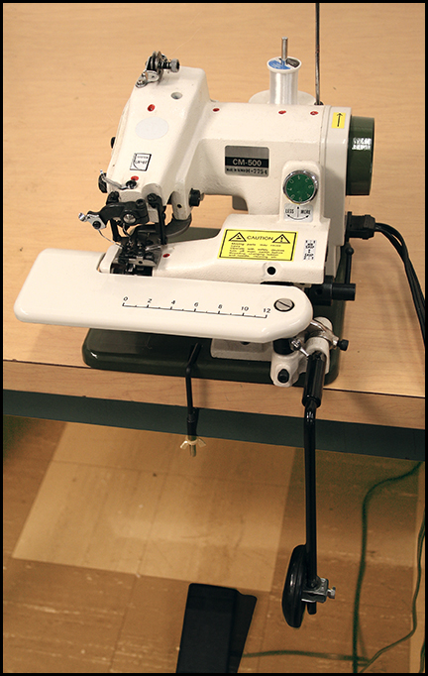  blind hem (pant hemming) machine with knee pedal to raise plate to insert fabric
- Make sure the equipment is secured to table top using a clamp. (Note: The table clamp inserts into a ridge at the centre of the base.)
Administrative Controls
- Provide adequate instruction on lab routines, job procedures, and equipment operation.

- Keep the work area clean and tidy at all times.
- Post safety signage.
- Follow the manufacturer’s directions for operation, maintenance, and safe practices.
- Inspect the machine regularly to ensure safe operation.
- Ensure a clear line of sight of all students on machines.
- Prevent cords from becoming trip hazards in
high-traffic areas.
- Tag and remove defective equipment from service.
- Arrange equipment to permit safe, efficient work practices and ease of movement and clean-up.

- Ensure ergonomic set-up of machine and furniture.
- Plug the cord into the machine first, and then plug the cord into the socket.
- Work at a safe speed. (The machine operates at a fast speed; therefore, make sure to caution beginners.)

- Check the settings on the machine before you start.

- Thread the machine when it is off.

- Make adjustments to the machine when the machine is stopped.

- Turn the handle wheel toward you. (This is unlike traditional sewing machines that are turned away from you.)

- Control the lowering and lifting of the plate with the knee pedal.

- Do not sew with any pressure against the knee pedal.
- Ensure that correct lighting is available.
- Inspect cords and plugs for fraying and exposed wires.
- Use the right needle for the chosen fabric weight.

- Use an industrial curve needle.

- Keep food and beverages away from the machine.
- Follow the school safety policy.

- Provide and document ongoing safety education and training, including mandatory equipment and tool orientation.

- Ensure tools are used under competent supervision.

- Ensure repetitive tasks are properly paced.

- Post important emergency telephone numbers and contacts.

- Post lockdown procedures.

- Post fire drill procedures.

- Establish handwashing practices.

- Ensure fire extinguishers are strategically located and marked.

- Provide a first aid kit and supplies, including an eyewash station and biohazard disposal.

- Correctly place and maintain smoke detectors and heat sensors.
Personal Protective Equipment (PPE)
- safety glasses or eye protection

