CLUSTER | NAT: NATURAL RESOURCES
OCCUPATION | Agriculture
HAZARD CONTROLS | TOOLS—FLORAL TOOLS
Engineering Controls | 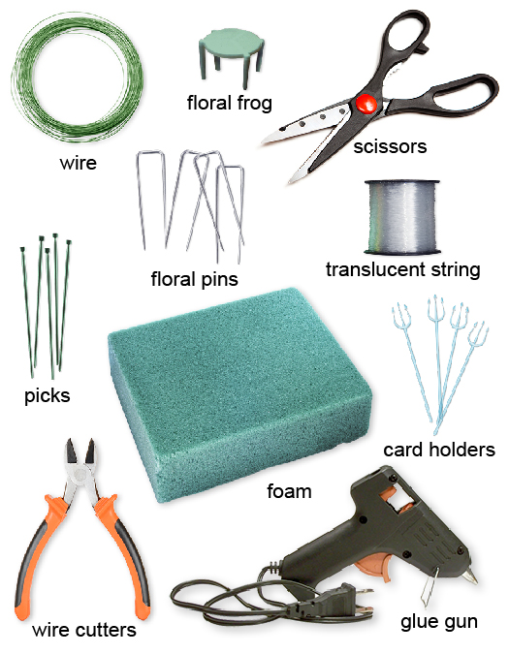  wire: Adapted from © PRILL/shutterstock; frog: Adapted from © Paul Orr/shutterstock; scissors: © AlexussK/shutterstock; string: Adapted from © Trudy Wilkerson/shutterstock; pins: Adapted from © gillmar/shutterstock; picks: Adapted from © mexrix/shutterstock; foam: © nito/shutterstock; card holders: Adapted from: Hemera/Thinkstock; glue gun: © R Perreault/shutterstock; wire cutters: © Andrei Kuzmik/shutterstock
- n/a
Administrative Controls
- Provide initial training to include a thorough review of hazards and accidents associated with the job.
- Follow the school safety policy.
- Provide and document ongoing safety education and training, including mandatory equipment and tool orientation.
- Be aware of sharp edges.

- Always point the blade or tip toward the ground when you are carrying a tool.

- Clean the tool when you are finished using it.

- Be aware of the sharp ends of the wire.

- Be aware that the glue gun and glue are very hot when in use.

- Unplug the glue gun when you are finished using it.

- Tag and remove defective tools from service.

- Ensure tools are used under competent supervision.

- Ensure the tool is appropriate for the work to be done.

- Ensure repetitive tasks are properly paced.

- Provide a first aid kit and supplies, including an eyewash station and biohazard disposal.

- Keep the manufacturer’s manual for the tool.

- Adhere to the Canadian Electrical Code during the operation, repair, and maintenance of equipment.

- Keep sharp tools sharpened.

- Establish handwashing practices.
Personal Protective Equipment (PPE)
- apron

