CLUSTER | NAT: NATURAL RESOURCES
OCCUPATION | Forestry
HAZARD CONTROLS | EQUIPMENT—BROADCAST SEEDER
Engineering Controls | 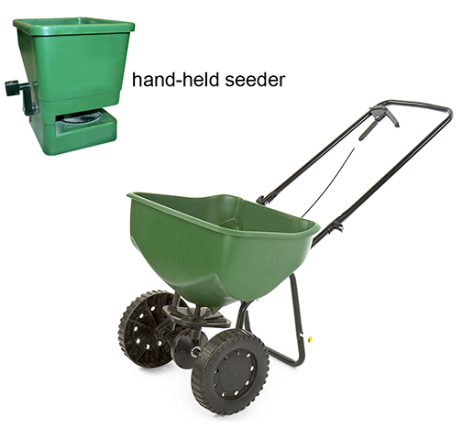  bottom image © Chris Roselli/13754086/Fotolia
- n/a
Administrative Controls
- Follow the school safety policy.
- Provide initial training to include a thorough review of hazards and accidents associated with the job.
- Provide and document ongoing safety education and training, including mandatory equipment and tool orientation.

- Tag and remove defective equipment from service.
- Ensure the equipment is appropriate for the work to be done.
- Keep the manufacturer’s manual for the tool. Read and follow manufacturer instructions, precautions and directions for proper safety, maintenance, and cleaning.
- Adjust the strap for comfort if using a hand-held unit.
- Keep your wrist as straight as possible while cranking a hand-held unit.
- Do not overload the unit. It should be comfortable to push (if using a push unit) or carry (if using a hand-held unit).
- Develop and communicate safe work practices and procedures for hazardous situations.
- Provide a first aid kid and supplies, including an eyewash station and biohazard disposal.
- Ensure repetitive tasks are properly paced.
- Establish handwashing practices.
- Ensure WHMIS training is available.
- Provide up-to-date MSDS.
- Secure and use the least toxic and harmful substance for the students and the environment.
Personal Protective Equipment (PPE)
- protective gloves
- high visibility jacket or vest if in forest
- protective footwear

