CLUSTER | NAT: NATURAL RESOURCES
OCCUPATION | Forestry
HAZARD CONTROLS | TOOL—HOE
Engineering Controls | 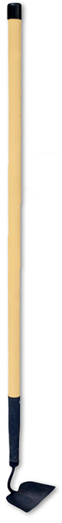  Hemera/Thinkstock
- n/a
Administrative Controls
- Provide initial training to include a thorough review of hazards and accidents associated with the job.
- Ensure the tool is in proper working order; e.g., make sure the handle is not loose or cracked.
- Tag and remove defective tools from service.

- Leave enough room around the person using the tool to allow leverage.

- Always clean the tool and store it properly when you are finished using it.

- Follow the school safety policy.

- Provide and document ongoing safety education and training, including mandatory equipment and tool orientation.

- Ensure tools are used under competent supervision.

- Ensure the tool is appropriate for the work to be done.

- Ensure repetitive tasks are properly paced.

- Provide a first aid kit and supplies, including an eyewash station and biohazard disposal.
Personal Protective Equipment (PPE)
- protective gloves
- polycarbonate or plastic protective glasses
- high-visibility jacket or vest when outdoors

