CLUSTER | NAT: NATURAL RESOURCES
OCCUPATION | Wildlife
HAZARD CONTROLS | EQUIPMENT—PERSONAL FLOTATION DEVICE
Engineering Controls | 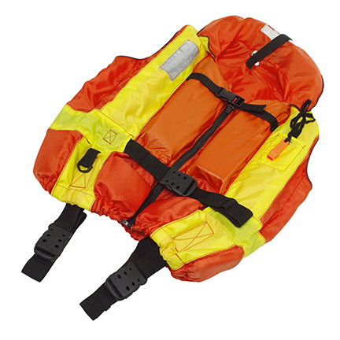  Stockbyte/Thinkstock
- Ensure that PFD is approved for use in Canada.
Administrative Controls
- Attach a whistle to the PFD or life jacket.

- Choose a PFD that is appropriate for activity and is a proper fit.

- Follow the school safety policy.

- Provide and document ongoing safety education and training, including mandatory equipment and tool orientation.

- Tag and remove defective tools from service.

- Establish handwashing practices.

- Provide a first aid kit and supplies, including an eyewash station and biohazard disposal.

- PFDs should be tested for buoyancy at the start of each season and on a regular basis throughout season.

- Keep the manufacturer’s manual for the tool. Read and follow manufacturer instructions, precautions, and directions for proper use, safety, maintenance, and cleaning.

- Develop and communicate safe work practices and procedures for hazardous situations.
Personal Protective Equipment (PPE)
- whistle

