CLUSTER | NAT: NATURAL RESOURCES
OCCUPATION | Wildlife
HAZARD CONTROLS | EQUIPMENT—GAS AUGER
Engineering Controls | 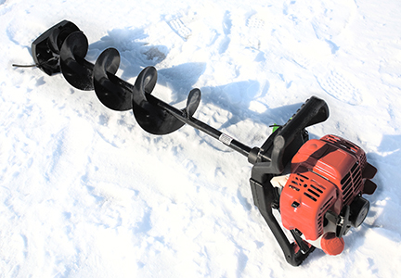  iStockphoto/Thinkstock
- Use machine guards when not in use.
Administrative Controls
- Choose an auger with adjustable height.

- Follow the school safety policy.

- Provide and document ongoing safety education and training, including mandatory equipment and tool orientation.

- Tag and remove defective tools from service.

- Ensure the equipment is appropriate for the work to be done.

- Schedule work to avoid overcrowding.

- Establish handwashing practices.

- Provide safe clearance for the equipment.

- Provide a first aid kit and supplies, including an eyewash station and biohazard disposal.

- Keep the manufacturer’s manual for the equipment. Read and follow manufacturer instructions, precautions, and directions for proper use, safety, maintenance, and cleaning.

- Provide initial trading to include a thorough review of hazards and accidents associated with the task.

- Develop and communicate safe work practices and procedures for hazardous work or situations.

- Vary tasks and limit the time any student spends on highly repetitive tasks to reduce the risk of musculoskeletal injuries.

- Maintain class supervision at all times.
Personal Protective Equipment (PPE)
- proper footwear, depending on the task
- protective glasses or goggles

