Graphic Organizer #25

Enter text into the fields below.

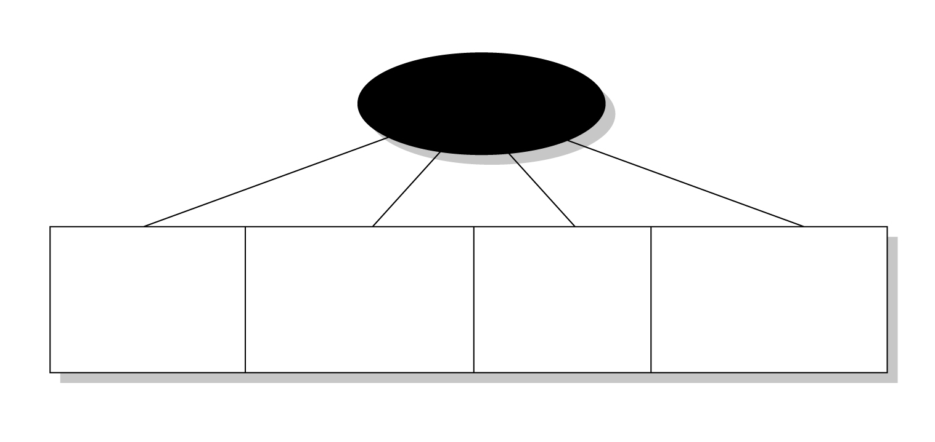
Text…
Text…
Text…
Text…
Text…
Sample

The sample question is provided as an illustrative example only. It is not intended for use with the 2005-2007 Alberta Social Studies Programs of Study.
