Graphic Organizer #5

Enter text into the fields below.
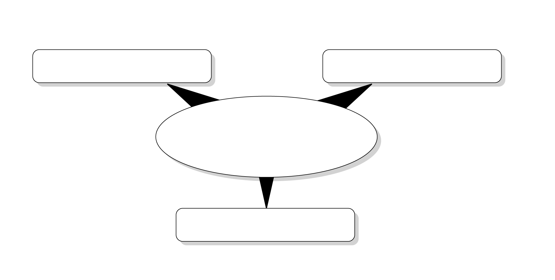
Text…

Text…

Text…

Text…

Sample
The sample question is provided as an illustrative example only. It is not intended for use with the 2005-2007 Alberta Social Studies Programs of Study.
